// Example 1

#include<iostream.h>

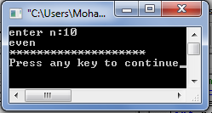void main()

{

int n;

cout<<"enter n:";

cin>>n;

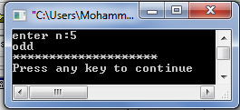 if(n%2==0)

cout<<"even \n";

else

cout<<"odd \n";

cout<<"\*\*\*\*\*\*\*\*\*\*\*\*\*\*\*\*\*\*\*\*\n";

}

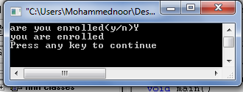// example 2

#include<iostream.h>

void main()

{

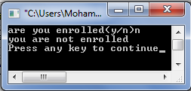 char ans;

cout<<"are you enrolled(y/n)";

cin>>ans;

if(ans=='Y'||ans=='y')

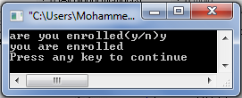 cout<<"you are enrolled\n";

else

cout<<"you are not enrolled\n";

}

//Example3

#include<iostream.h>

void main()

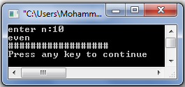{ int n;

cout<<"enter n:";

cin>>n;

if(n%2==0)

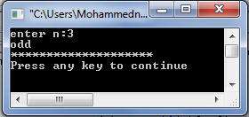 {

cout<<"even \n";

cout<<"##################\n";

}

else

{

cout<<"odd \n";

cout<<"\*\*\*\*\*\*\*\*\*\*\*\*\*\*\*\*\*\*\*\*\n";

}

}

//Example4

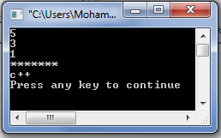#include<iostream.h>

void main()

{

int x,y,z;

cin>>x>>y>>z;

if(x>y && y>z || !(y==3))

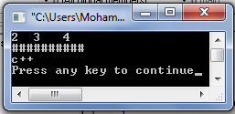 cout<<"\*\*\*\*\*\*\*\n";

else

cout<<"##########\n";

cout<<"c++"<<endl;

}

// example 5

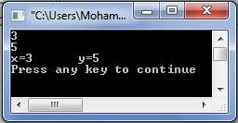#include<iostream.h>

void main()

{

int x,y;

cin>>x>>y;

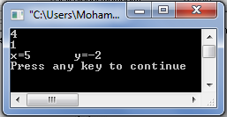if(((x+y)%3==0) || ((x+y)%5==0))

{

x=x+1;

y=y-3;

cout<<"x="<<x<<"\t y="<<y<<endl;

}

else

cout<<"x="<<x<<"\t y="<<y<<endl;

}

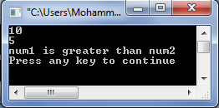// example 6

#include<iostream.h>

void main()

{

int num1,num2;

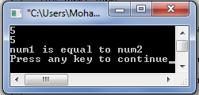cin>>num1>>num2;

if(num1>num2)

cout<<"num1 is greater than num2"<<endl;

else

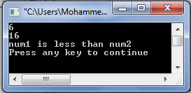if(num1==num2)

cout<<"num1 is equal to num2"<<endl;

else

cout<<"num1 is less than num2"<<endl;

}

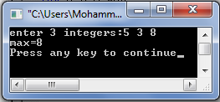// example 7

#include<iostream.h>

void main()

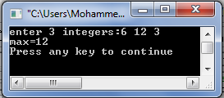{

int a,b,c,max;

cout<<"enter 3 integers:";

cin>>a>>b>>c;

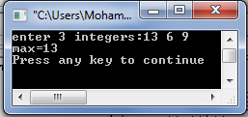if(a>=b && a>=c) max=a;

if(b>=a && b>=c) max=b;

if(c>=a && c>=b) max=c;

cout<<"max="<<max<<endl;

}

//example 8 same as example 7

#include<iostream.h>

void main()

{

int a,b,c,max;

cout<<"enter 3 integers:";

cin>>a>>b>>c;

if(a>b)

if(a>c)

max=a;

else

max=c;

else

if(b>c)

max=b;

else

max=c;

cout<<"max="<<max<<endl;}

// example 9 same as example 7 and 8

#include<iostream.h>

void main()

{

int a,b,c,max;

cout<<"enter 3 integers:";

cin>>a>>b>>c;

max=a;

if(b>max)

max=b;

if(c>max)

max=c;

cout<<"max="<<max<<endl;

}

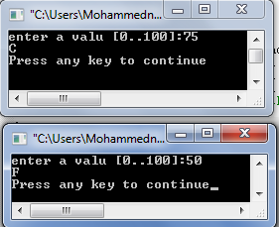// example 10

#include<iostream.h>

void main()

{

int m;

cout<<"enter a valu [0..100]:";

cin>>m;

if(m<=100 && m>=90) cout<<"A"<<endl;//[100,90]

if(m<90 && m>=80) cout<<"B"<<endl;//(90,80]

if(m<80 && m>=70) cout<<"C"<<endl;//(80,70]

if(m<70 && m>=60) cout<<"D"<<endl;//(70,60]

if(m<60) cout<<"F"<<endl;//less than 60

}

// example 11 same as example 10

#include<iostream.h>

void main()

{

int m;

cout<<"enter a valu [0..100]:";

cin>>m;

if( m>=90) cout<<"A"<<endl;//[100,90]

else if( m>=80) cout<<"B"<<endl;//(90,80]

else if( m>=70) cout<<"C"<<endl;//(80,70]

else if( m>=60) cout<<"D"<<endl;//(70,60]

else

cout<<"F"<<endl;//less than 60

}

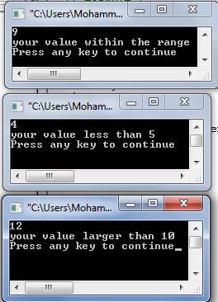// example12

#include<iostream.h>

void main()

{

int m;

cin>>m;

if(m<=10)

if(m>=5)

cout<<"your value within the range\n";

else

cout<<"your value less than 5\n";

else

cout<<"your value larger than 10\n";

}

// example 13 same as example 12

#include<iostream.h>

void main()

{

int m;

cin>>m;

if(m<=10 && m>=5)

cout<<"your value within the range\n";

else

if (m <=5) cout<<"your value less than 5\n";

else

cout<<"your value larger than 10\n";

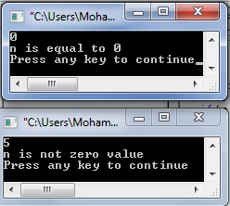}

// example 14

#include<iostream.h>

void main()

{

int n;

cin>>n;

if(n)

cout<<"n is not zero value\n";

else

cout<<"n is equal to 0\n";

}

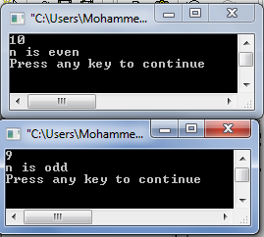// example 15

#include<iostream.h>

void main()

{

int n;

cin>>n;

if(n%2)

cout<<"n is odd\n";

else

cout<<"n is even\n";

}

//example 16

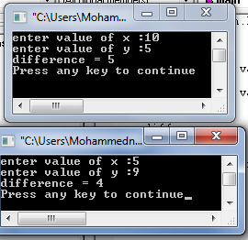#include<iostream.h>

void main()

{ int x,y;

int diff;

cout<<"enter value of x :" ;

cin>>x ;

cout<<"enter value of y :" ;

cin>>y;

if (x>y)

diff =x-y;

else

diff=y-x;

cout<<"difference = "<<diff<<endl;

}

//example 17

#include<iostream.h>

main()

{ int side ;

float base,height,area;

char shape;

cout<<" To compute the area of a square(s) or a traingle(t) :"<<endl;

cout<<"please enter the first character of the figure name:(t or s):";

cin>>shape;

if (shape=='s' )

{

cout<<"enter side of square:";

cin>>side;

area=side\*side;}

if (shape=='t')

{

cout<<"enter base:";

cin>>base;

cout<<"enter height:";

cin>>height;

area= (base+height)/2;

}

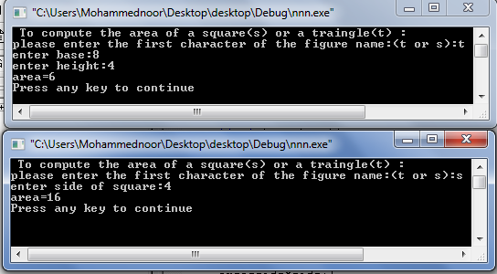 cout<<"area="<<area<<endl;}

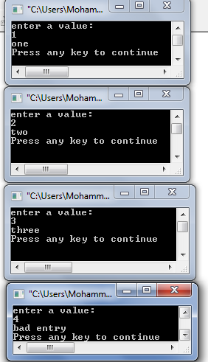//example 18

#include<iostream.h>

void main()

{

int num;

cout<<"enter a value:\n";

cin>>num;

switch(num)

{

case 1: cout<<"one\n";break;

case 2:cout<<"two\n";break;

case 3:cout<<"three\n";break;

default : cout<<"bad entry\n";break;//optional

}

}

//example 19

#include<iostream.h>

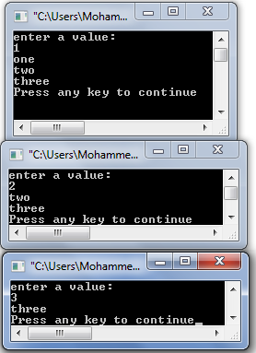void main()

{

int num;

cout<<"enter a value:\n";

cin>>num;

switch(num)

{

case 1: cout<<"one\n";

case 2:cout<<"two\n";

case 3:cout<<"three\n";break;

default : cout<<"bad entry\n";break;

}

}

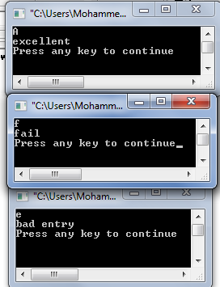//example 20

#include<iostream.h>

void main()

{

char ch;

cin>>ch;

switch(ch)

{

case 'a':

case 'A':cout<<"excellent\n";break;

case 'b':

case 'B': cout<<"very good\n";break;

case 'c':

case 'C': cout<<"good\n";break;

case 'f':

case 'F':cout<<"fail\n";break;

default : cout<<"bad entry\n";break;

}

}